RV College of Engineering®
(Autonomous Institution Affiliated to VTU, Belagavi)
BENGALURU – 560 059

Real Time Cashew Kernel Classification Using Deep Learning
INTERDISCIPLINARY PROJECT DIARY
Team Number: 190

Student’s Name | USN | Department
RAVIKANT | 1RV23EC408 | ECE
SAGAR T NAYAK | 1RV23EC410 | ECE
YOGEESH A S | 1RV23BT404 | BT
KIRAN H R | 1RV23CS405 | CSE
MANOJ KUMAR B V | 1RV23CS407 | CSE

Under the guidance of
Dr. Veena Devi S V
Associate Professor
Department of Electronics and Communication Engineering

VI SEMESTER - B.E.
2024-25

Interdisciplinary Project Synopsis

INTRODUCTION:
Cashew kernels are a valuable product in the global food market, and their quality affects both price and consumer choice. Traditionally, kernels are graded by hand based on size, shape, color, and surface condition. Skilled workers visually inspect and sort them into categories like whole, split, or scorched. However, manual grading is slow, tiring, and prone to mistakes, leading to inconsistencies in quality and profit loss. To solve this, the industry is moving toward automation using artificial intelligence and computer vision. Deep learning is especially useful because it can learn to recognize complex visual patterns from large sets of images. This project focuses on developing a real-time system that automatically classifies cashew kernels using deep learning. It aims to replace manual inspection with a faster, more reliable, and scalable method, helping improve product quality, reduce labor needs, and boost overall efficiency in cashew processing.
OBJECTIVES:
- Design an Image processing unit for capture the raw cashew kernel images and data preprocessing.
- Implement an Algorithm for data analysis, feature extraction and classification to determine the variations in the raw cashew kernels.
- Employ AI algorithms to classify and grade cashew defects.
- Integrate robust hardware and software for efficient testing and grading.
METHODOLOGY:
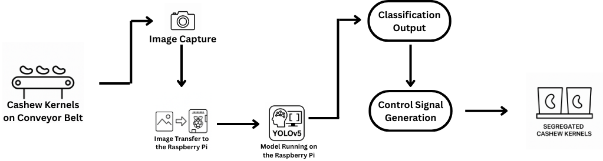

- Image Acquisition & Preprocessing: Capture diverse cashew kernel images and apply preprocessing (resizing, normalization, augmentation) to build a consistent dataset.
- Labeling & Model Training: Manually label kernels by grade (whole, split, scorched, etc.) and train a deep learning model (e.g., YOLO) for classification.
- Real-Time Classification: Deploy the model on edge devices for real-time detection and grading of kernels on a moving conveyor.
- Hardware Integration: Connect the classifier to microcontrollers (e.g., Arduino) and sensors to control actuators for sorting.
- Automated Sorting: Sort kernels into graded bins using actuators, enabling efficient and consistent automated grading.

SOFTWARE REQUIREMENTS:
- Python (with PyTorch/TensorFlow, OpenCV, NumPy, Pandas)
- Labeling Tools (e.g., CVAT, LabelMe)
- Libraries for feature extraction VGG16, ResNet50, ResNet101, InceptionV3.
- GUI framework (Tkinter / PyQT / Streamlit)
- MATLAB (for comparison or validation analysis)

HARDWARE REQUIREMENTS:
- High-resolution Camera
- Raspberry Pi
- Lighting Setup for consistent image capture
- Conveyer System, Stepper Motor
- GPU-enabled laptop or workstation

INTERDISCIPLINARY RELEVANCE:
- Electronics and Communication Engineering:
  - Responsible for the hardware setup, including the selection and integration of the camera, and other sensors.
  - Design and implementation of communication protocols for interfacing with the embedded system.
  - Control and automation of the Cashew classification system through electronics and embedded programming.

- Computer Science and Engineering:
  - Responsible for the software development, including image processing, machine learning model implementation, and system integration.
  - Applying algorithms for defect detection, classification, and feature extraction.
  - Developing a GUI for real-time monitoring and control, as well as database management.
- Biotechnology:
  - Defines quality parameters of cashew kernels based on biological and nutritional standards to guide accurate classification.
  - Supports dataset labeling and validation using domain knowledge to identify visual and biochemical defects.
  - Ensures the system aligns with industry standards by providing insights into biological variations affecting kernel quality.

INNOVATION / CONTRIBUTION TO THE FIELD:
- Develops a real-time deep learning-based system for accurate and automated classification of cashew kernels.
- Replaces traditional manual grading methods, reducing human error, labor dependency, and subjectivity.
- Incorporates image acquisition, pre-processing, and classification in a seamless pipeline suitable for industrial deployment.
- Enables consistent, scalable, and objective quality grading based on visual attributes such as shape, size, and surface defects.
- Enhances processing efficiency and product uniformity, contributing to improved profitability and quality assurance in the cashew industry.

GANTT CHART:
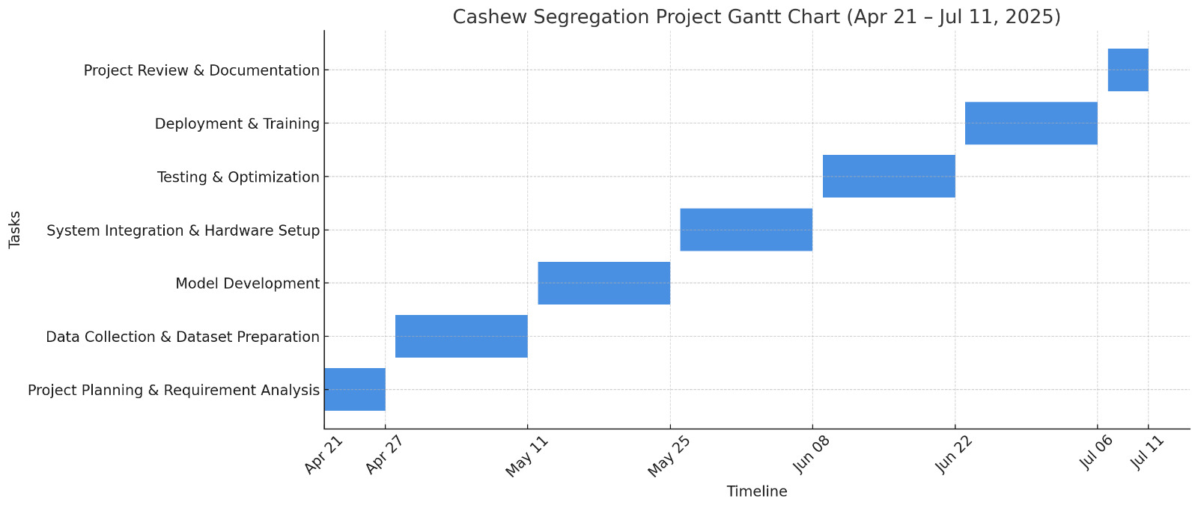

Signature Signature
Internal Guide Dean Academics

Name: Dr. Veena Devi S V
Designation: Associate Professor
Department: ECE
REPORT OF ACTIVITY CARRIED OUT

Sl. No. | Week wise plan | Activities carried out
1. | From Date: 21/04/2025  To Date: 26/04/2025
Guide Remarks:
Guide Signature with Date:

Sl. No. | Week wise plan | Activities carried out
2. | From Date: 28/04/2025  To Date: 03/05/2025
Guide Remarks:
Guide Signature with Date:

REPORT OF ACTIVITY CARRIED OUT

Sl. No. | Week wise plan | Activities carried out
3 | From Date: 05/05/2025  To Date:  10/05/2025
Guide Remarks:
Guide Signature with Date:

Sl. No. | Week wise plan | Activities carried out
4 | From Date:  12/05/2025  To Date:  17/05/2025
Guide Remarks:
Guide Signature with Date:

REPORT OF ACTIVITY CARRIED OUT

Sl. No. | Week wise plan | Activities carried out
5 | From Date:  19/05/2025  To Date:  24/05/2025
Guide Remarks:
Guide Signature with Date:

Sl. No. | Week wise plan | Activities carried out
6 | From Date:  26/05/2025  To Date:  31/05/2025
Guide Remarks:
Guide Signature with Date:

REPORT OF ACTIVITY CARRIED OUT

Sl. No. | Week wise plan | Activities carried out
7 | From Date:  02/06/2025  To Date:  07/06/2025
Guide Remarks:
Guide Signature with Date:

Sl. No. | Week wise plan | Activities carried out
8 | From Date:  09/06/2025  To Date:  14/06/2025
Guide Remarks:
Guide Signature with Date:

REPORT OF ACTIVITY CARRIED OUT

Sl. No. | Week wise plan | Activities carried out
9 | From Date:  16/06/2025  To Date:  21/06/2025
Guide Remarks:
Guide Signature with Date:

Sl. No. | Week wise plan | Activities carried out
10 | From Date:  23/06/2025  To Date:  28/06/2025
Guide Remarks:
Guide Signature with Date:

REPORT OF ACTIVITY CARRIED OUT

Sl. No. | Week wise plan | Activities carried out
11 | From Date:  30/06/2025  To Date:  05/07/2025
Guide Remarks:
Guide Signature with Date:

Sl. No. | Week wise plan | Activities carried out
12 | From Date:  07/07/2025  To Date:  11/07/2025
Guide Remarks:
Guide Signature with Date:

Phase I Date of Presentation: _________________

Committee Remarks:

Guide Signature

Phase II Date of Presentation: _________________

Committee Remarks:

Guide Signature

Phase III Date of Presentation: _________________

Committee Remarks:

Guide Signature

Project Presentation

Outcome of the Project

Guide Signature

RUBRICS FOR EVALUATION (THREE PHASES) INTERDISCIPLINARY PROJECT

Course Code | CS367P | Course Title | Interdisciplinary Project
Credits | 0:0:3 | CIE | 100 Marks
 |  | SEE | 100 Marks

PHASE I |  |  |  |  |  | PHASE II |  |  |  |  | PHASE III(Exhibition Mode)
Problem Definition+ Synosis Submission | Literature Survey | Objectives | Methodology | Total |  | Partial Project Execution | Tools and Techniques Used | Partial Results | Total |  | Complete Prototype Demonstration | Results & Discussions | Draft Paper &  Report | Poster & PPT demonstration | Total | Total
10 | 5 | 5 | 10 | 30 |  | 15 | 10 | 10 | 35 |  | 05 | 5 | 15 | 10 | 35 | 100

Phase-I: Problem Definition
Criteria | Excellent (10-8) | Very Good (7-6) | Good (5-4) | Satisfactory (3-2) | Needs Improvement (1-0)
Clarity | Clearly and concisely defines the interdisciplinary problem with specific focus and feasibility. | Clearly defines the problem but could improve conciseness. | Defines the problem but lacks specificity or focus. | Problem is vaguely defined or lacks feasibility. | Problem is unclear or not well-defined.
Relevance | Highly relevant to all three disciplines, addressing significant challenges. | Relevant and significant to two disciplines. | Somewhat relevant to one or two disciplines. | Relevance to the interdisciplinary context is unclear. | Not relevant to the domains of study.
Context | Provides a thorough background with technical, economic, and societal impact. | Provides adequate background with limited impact discussion. | Provides some background but lacks depth. | Provides minimal background. | No background or context provided.
Synopsis | Submitted synopsis in the given format | Submitted synopsis in the given format | Submitted synopsis in the given format | Submitted synopsis not in the given format | Not submitted synopsis

Phase-I: Literature Survey
Criteria | Excellent (5) | Very Good (4) | Good (3) | Satisfactory (2) | Needs Improvement (1)
Coverage & Relevance | Comprehensive review of key, credible sources; strong interdisciplinary focus. | Adequate coverage but misses some relevant works or lacks depth in places. | Limited or irrelevant sources; no clear connection to the research problem. | Comprehensive review of key, credible sources; strong interdisciplinary focus. | Adequate coverage but misses some relevant works or lacks depth in places.
Critical Analysis | In-depth comparison of methods/results; highlights strengths and weaknesses. | Summarizes sources but lacks synthesis or critique. | Only paraphrases sources; no analysis or evaluation. | In-depth comparison of methods/results; highlights strengths and weaknesses. | Summarizes sources but lacks synthesis or critique.
Research Gap Identification | Clearly articulates unresolved questions or limitations in existing literature. | Mentions gaps briefly but lacks clarity or justification. | No identification of gaps; only repeats existing findings. | Clearly articulates unresolved questions or limitations in existing literature. | Mentions gaps briefly but lacks clarity or justification.

Phase-I: Objectives
Criteria | Excellent (5) | Very Good (4) | Good (3) | Satisfactory (2) | Needs Improvement (1)
Specificity | Objectives are well-defined, measurable, and aligned with all three disciplines. | Objectives are clear but not fully specific to all disciplines. | Objectives are somewhat clear but lack measurable aspects. | Objectives are vague or lack clarity. | No clear objectives.
Alignment | Strong alignment with the problem definition and interdisciplinary approach. | Mostly aligned with the problem definition. | Partial alignment with interdisciplinary relevance. | Weak alignment with problem definition. | No alignment with problem definition.
Feasibility | Objectives are achievable given the technical constraints and scope. | Objectives are challenging but feasible. | Objectives are somewhat realistic but could be improved. | Objectives are unrealistic or difficult to achieve. | Objectives are not achievable.

Phase-I: Methodology
Criteria | Excellent (10-8) | Very Good (7-6) | Good (5-4) | Satisfactory (3-2) | Needs Improvement (1-0)
Appropriateness | Methodology is well-suited for objectives and integrates all three disciplines perspectives. | Methodology is appropriate but has minor gaps in interdisciplinary integration. | Methodology addresses only one or two disciplines adequately. | Methodology is somewhat inappropriate for interdisciplinary scope. | Methodology is inappropriate or missing.
Detail | Detailed methodology with clear workflow and implementation plan. | Mostly detailed with minor gaps. | Lacks some documentation or clarity. | Poorly detailed with minimal documentation. | No methodology or poorly documented.
Flowchart | Well-structured flowchart with clear representation of all steps. | Accurate flowchart but missing some details. | Flowchart lacks clarity in key steps. | Incomplete flowchart with missing information. | No or incorrect flowchart.

Phase-II: Partial Project Execution
Criteria | Excellent (15-12) | Very Good (11-8) | Good (7-4) | Satisfactory (3-2) | Needs Improvement (1-0)
Adherence | Follows methodology strictly with well-documented progress. | Follows methodology with minor deviations. | Some deviations from methodology but still relevant. | Major deviations impacting quality. | No adherence to methodology.
Timeliness | Completed on schedule with milestones met. | Minor delays but within scope. | Noticeable delays affecting project execution. | Significant delays impacting deliverables. | Not completed on time.
Quality | High-quality results with proper validation. | Good quality with minor technical issues. | Acceptable quality with noticeable gaps. | Poor quality with significant issues. | Very poor or incomplete work.

Phase-II: Tools & Techniques Used
Criteria | Excellent (10-8) | Very Good (7-6) | Good (5-4) | Satisfactory (3-2) | Needs Improvement (1-0)
Selection | Tools and techniques are cutting-edge and suitable for interdisciplinary work. | Appropriate tools are selected but minor improvements needed. | Somewhat relevant tools but lacking efficiency. | Tools are outdated or not well-suited. | No tools or inappropriate selection.
Application | Tools are expertly applied for optimal results. | Effectively applied but with minor issues. | Adequately applied with gaps in efficiency. | Poor application with minimal impact. | No application or incorrect use of tools.
Integration | Tools are seamlessly integrated into the project workflow. | Well-integrated with minor issues. | Some integration but lacks cohesion. | Poorly integrated. | No integration or incorrect application.

Phase-II: Partial Results
Criteria | Excellent (10-8) | Very Good (7-6) | Good (5-4) | Satisfactory (3-2) | Needs Improvement (1-0)
Clarity | Partial results are well-documented and clearly explained. | Clear results with minor gaps. | Some clarity but lacks detail. | Unclear results with minimal documentation. | No partial results or poor documentation.
Progress | Significant progress with meaningful insights. | Good progress but needs more refinement. | Some progress but lacks depth. | Minimal progress. | No progress.
Analysis | Thorough analysis with interdisciplinary insights. | Good analysis with some depth. | Basic analysis with minor gaps. | Poor analysis with little interpretation. | No analysis or misinterpretation.

Phase-III: Complete Prototype Demonstration (Hardware/Software)
Criteria | Excellent (5) | Very Good (4) | Good (3) | Satisfactory (2) | Needs Improvement (1)
Functionality | Fully functional, meeting all objectives. | Functional with minor issues. | Works but has noticeable issues. | Major issues affecting usability. | Not functional.
Innovation | Highly innovative and demonstrates creative problem-solving. | Shows good levels of innovation. | Some innovation but lacks novelty. | Minimal innovation. | No innovation.
Usability | Highly user-friendly and intuitive. | User-friendly with minor issues. | Some usability but needs improvement. | Difficult to use. | Not usable.

Phase-III: Results & Discussion
Criteria | Excellent (5) | Very Good (4) | Good (3) | Satisfactory (2) | Needs Improvement (1)
Clarity | Results are well-explained and presented effectively. | Clear results with minor explanation gaps. | Somewhat clear but needs more explanation. | Unclear or poorly explained results. | No results or highly unclear.
Analysis | Insightful and in-depth analysis with strong validation. | Good analysis but minor gaps in reasoning. | Adequate analysis with basic insights. | Limited analysis with few insights. | No analysis or incorrect interpretation.
Interpretation | Logical and well-supported conclusions. | Mostly logical with minor flaws. | Some logical interpretations but weak justification. | Poorly supported conclusions. | No interpretation or illogical reasoning.

Phase-III: Report and Research Paper Writing
Criteria | Excellent (15-12) | Very Good (11-8) | Good (7-4) | Satisfactory (3-2) | Needs Improvement (1-0)
Report Organization | Well-organized, logical structure with clear headings and subheadings | Clear organization, minor lapses in flow | Basic organization, some sections could be more logically arranged | Poor organization, hard to follow | No clear organization, difficult to navigate
Plagiarism | No plagiarism, proper citations for all sources used | Few minor citation errors, no unintentional plagiarism | Some citations missing, but no evidence of deliberate plagiarism | Several sources without citation or improper citation | Clear evidence of plagiarism, missing citations or incorrect use
Paper Submitted to Conference/Journal | Submitted to a relevant and high-quality conference/journal | Submitted to an appropriate conference/journal with some relevance | Submitted to a less relevant conference/journal | Submitted to a low-impact or inappropriate conference/journal | Not submitted or submitted to an irrelevant conference/journal
Paper Accepted in Conference/Journal | Accepted in a reputable conference/journal with peer-reviewed status | Accepted in a well-regarded conference/journal | Accepted in a less prestigious conference/journal | Accepted in a minor or non-peer-reviewed journal | Not accepted in any conference/journal

Phase-III: Poster, PPT and Exhibition

Criteria | Excellent (10-8) | Very Good (7-6) | Needs Improvement (5-0)
Poster | Highly organized, visually appealing, and effectively conveys the message | Good organization and design with minor issues in clarity or visual appeal | Poor organization or cluttered design, difficult to understand
PPT | Well-structured, clear, engaging slides with excellent visual design | Good structure and design, minor issues in clarity or engagement | Disorganized or hard-to-follow slides, poor visual design or presentation
Exhibition | Highly engaging, interactive, and informative, capturing audience attention | Good interaction and information, mostly engaging with minor issues | Minimal interaction, hard to maintain audience attention, lacking clarity

Phase Evaluation:
Sl.  No. | USN | PHASE EVALUATION | PHASE-1 |  |  |  |  | PHASE-2 |  |  |  | PHASE-3
Sl.  No. | USN | MAX MARKS | 10 | 5 | 5 | 10 | 30 | 15 | 10 | 10 | 35 | 5 | 5 | 15 | 10 | 35
Sl.  No. | USN | COs Mapped | 1 | 2 | 1 | 1 |  | 3 | 4 | 4 |  | 4 | 4 | 3 | 3
Sl.  No. | USN | NAME
1 | 1RV23EC408 | RAVIKANT
2 | 1RV23EC410 | SAGAR T NAYAK
3 | 1RV23BT404 | YOGEESH A S
4 | 1RV23CS405 | KIRAN H R
5 | 1RV23CS407 | MANOJ KUMAR B V

CIE Marks:

Sl. No. | USN | NAME | I Phase  (30) | II Phase  (35) | III Phase  (35) | Total (100)
1 | 1RV23EC408 | RAVIKANT
2 | 1RV23EC410 | SAGAR T NAYAK
3 | 1RV23BT404 | YOGEESH A S
4 | 1RV23CS405 | KIRAN H R
5 | 1RV23CS407 | MANOJ KUMAR B V

Signature of Internal Guide Name: Dr. Veena Devi S V Designation: Associate Professor  Department: ECE  RV College of Engineering | Signature of the HOD  Name: Dr. H V Ravish Aradya  Department: ECE  RV College of Engineering

